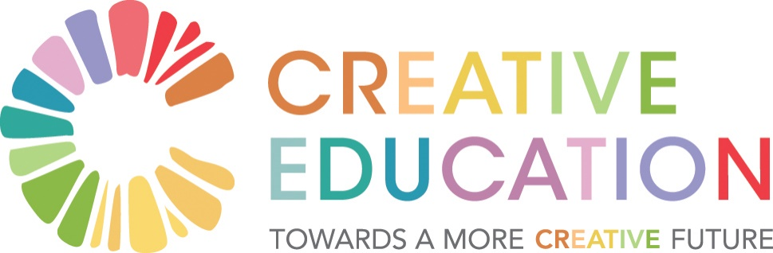

**Themes from Concluding Circle**

The concluding reflections of participants were framed by the question of how to create a transition to a more creative education system that is as productive and rewarding as possible for all concerned? The following themes emerged, reflected in participants own words:

* **The Current Context**: ‘Anne Madden has sent, as a gift, a card with two bumble bees and the legend: ‘*To ‘bee’ or not to ‘bee’* which reminds us of the precarious nature of the environment for these creatures.’ ‘We have new opportunities with SC reform and new primary curriculum.’ ‘Just as the ‘Wild Atlantic Way’ gave us a new way to view what already existed these days give us a new way to view education. This special place gave us the strength to excavate all our assumptions.’
* **Values/Purpose**: ‘We need to engender common values’. ‘We have an opportunity with the senior cycle to explore values.’ ‘In the 21st century, education is for being citizens of the world and recovering a sense of the common good. How to change the focus from a sovereignty of the self.’ ‘We are more generous than we thought -we are ready to park religious and other hang-ups and place well-being centre stage.’ ‘We need deep listening to the voice of the system and the teacher and keep humanity at the centre of the work.’ ‘The marginalised are not in our midst though there are voices speaking on their behalf to say if we can address marginalisation we address what’s needed in the system as a whole.’ ‘Education should be compelling as well as compulsory.’ ‘We need the organ of the heart in education.’ ‘I’m looking for an Irish sense of education. It needs heart.’ ‘My favourite music is the Irish language. What stems from our ‘dúchas’ are time, space, respect and nourishment. ‘Tá dóchas sa dúchas’.
* **Creativity & the Arts**: ‘Creativity will be stultified by top-down approaches. We need to tackle vested interests and move forward.’ ‘I would like creativity not to be stultified by a top-down system.’ ‘Firstly a note of caution, this stuff is hard. What is creativity? It will take a lot of work to understand.’ ‘Ask people to inculcate a space for the arts to breathe.’ ‘Creativity is what makes us human. We are here to witness the beauty of the universe.’ ‘ John O’Donohue said leadership is about bridging memory and possibility. This feels like a definition of creativity. His poem brought soul and memory into the room. We are not linear people.’ ‘Creativity is about being a whole person.’ ‘Creativity resides in the space between.’ ‘What does it feel to have creativity all around us.’ ‘Creative education should be a corner stone.’ ‘Artists needs this process as well – to become the maximum of who we are.’
* **Process for Moving Forward**: ‘I want to carry the conversation process forward.’ ‘It’s difficult to get involvement in such a huge system with 4,000 schools.’ ‘Ireland is a place where conversation is still a sacrament - this Symposium will resonate out into wider society.’ ‘I don’t know where this is going but I hope it’s the start of something big. We’ve been broken down and made to open. There is the making of something big. The group needs to reconvene.’ ‘We are beautiful people. I implore everyone to be a community of doers.’ ‘We need to listen and do.’ ‘The education system doesn’t need reinventing. It just needs everyone to do the thing they are taking away.’ ‘These three days give hope that it is possible to make things happen.’ ‘Try creative solutions – don’t think too much.’ ‘Look out the window at the world of business. Tap into the skills and expertise that are available as well as other resources.’ ‘Everyone is a note in the performance. There is a ripple effect we can have on people we meet.’ ‘We are all learners.’ ‘We need to plant the seeds of change. What are the essential notes?’ ‘Being in the Burren gave a ‘sos’ from product to focus on process. I will now consider new ways of doing in my context.’ ‘I will take back new ideas and perspectives.’ ‘We are the system. We need to liberate ourselves and the system. We all have influence and there are many others outside the room who share our vision about a more resilient future. Give courage to decision-makers.’ ‘It will take a while to process. I play my drawings.’ ‘I’m renewed in my determination. We are growing in the immeasurability of ourselves.’ Suspend making meaning for as long as possible. The more you suspend the more the future can be richer.’
* **Citizens Assembly** **for Educational Reform**: ‘The egotistical rationality of our education system has got us here. We need a Citizens Assembly.’ ‘What’s possible when we cease being afraid – is my learning. If we feel stuff is happening that is suffocating we are called to act. I will pursue what’s emerging - a Citizens Assembly for Educational Reform.’ ‘Allow others to experience the ‘tobar’ of renewal. The Citizens Assembly is a great way to celebrate values and be renewed. Teachers learn when out of the classroom and can be vulnerable. We have been out of our comfort zone and at the ‘tobar’.’ ‘Could a Citizens Assembly meet in this space to be nourished by the Burren and Burren College?’ ‘I’m pledging myself as a foot-soldier of the Citizens Assembly for Educational Reform.’ ‘Insights are increasing. Scolarship leads to understanding which leads to action. I see the Citizens Assembly as important and Senior Cycle reform as very important. We have an opportunity for a civic dialogue.’
* **Students and Teachers**: ‘I’m arguing for children’s voice.’ ‘50% of the Citizens’ Assembly should be children.’ ‘Thanks to my teachers for allowing me to be part of this.’ ‘Thanks for giving me the opportunity of being in this inspiring circle. These three days give hope that it is possible to make things happen.’ ‘I’m glad students did facilitation – it was very powerful.’ ‘I’m enthusiastic that my students can make a difference.’ ‘Allow teachers to experience the ‘tobar’ of renewal. Teachers learn when out of the classroom and can be vulnerable.’ ‘I love my work as teacher – I’m not sure the system loves me as much. Bring back a pedagogy of care and place.’ ‘I came because education is important and the teacher has the single most important role.’ ‘Teachers have transformed my live. For many school wasn’t a transformative experience. I want to carry the conversation process forward.’ ‘We must take care of our teachers - there is invisibility in education.’ ‘I’m feeling joy and inspiration from students and teachers.’
* **Final Word**: ‘I won’t remember what you said but I will carry with me how you made me feel.’