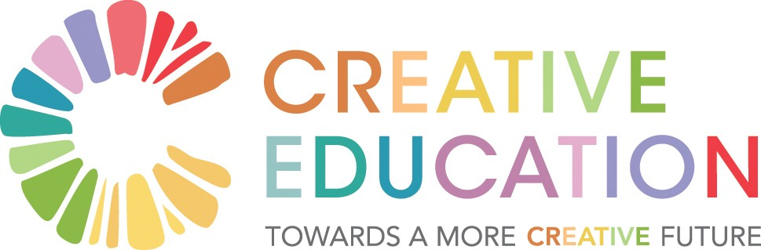

Symposium: ‘Towards a More Creative Education System’

‘The Power of Ideas whose time has come’

19-22 September, 2018
Burren College of Art, Ballyvaughan

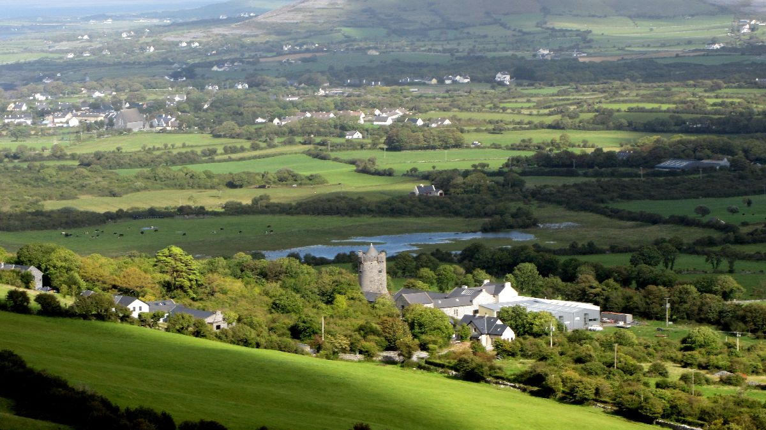
Invitation to a Conversation
‘Towards a More Creative Education System’ is an invitation to be part of a creative conversational process aimed at moving the education system at national and local levels in the direction of the greater creativity, student agency and resilience that are now recognized as essential in the 21st century. The Symposium, which is reported on here, was designed as a powerful catalyst and launching pad for this conversation. Everyone, from students and parents to academics and policy makers, is invited to participate.
This brief report relies heavily on images to convey the power of the creative conversational processes that were deployed. It sets out the ideas that inspired the Symposium, the creative processes by which it was facilitated, the major themes that were surfaced in its four strands and the initiatives which are emerging to sustain the conversation into the future. We hope that as many people as possible will choose to be part of this conversation which is profoundly important for the wellbeing of our society at this time of extraordinary global change.
A foundational impulse for the conversation was the idea proposed by artist Joseph_Beuys that ‘Everybody is an artist’, by which he meant that everybody has the capacity to be creative in everything they do. This insight seemed particularly apt at time when a consensus was emerging internationally that education systems needed to be more creative if they were to deal with a world where Volatility, Uncertainty, Complexity and Ambiguity (VUCA) were the new normal. This imperative was recognized in the OECD’s 2018 position paper Education 2030.
Confronted with the reality of disruptive change evident in the domains of artificial intelligence, climate change, political discourse and much else, the education system needed to place student agency centre stage, empowering students to be creative and resilient in response. Education needed to be concerned with whole-student learning, cultivating interior conditions and capacities, not just memorising old knowledge. In effect much of the traditional focus of the education system needed to be upended!
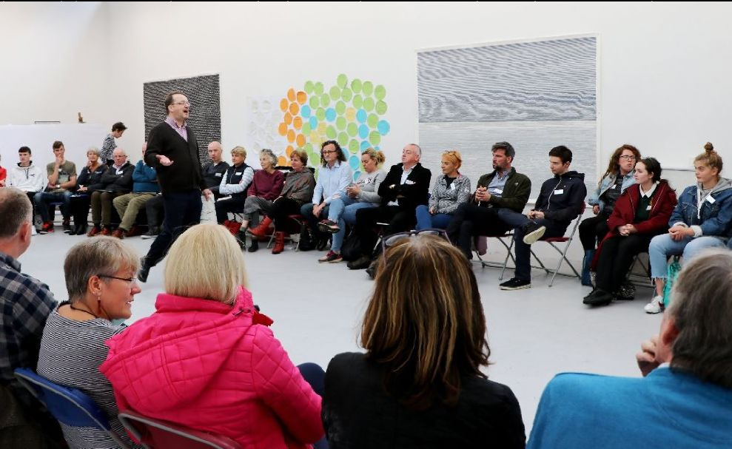

“In the 21st century, education is for being citizens of the world and recovering a sense of the common good.”
“Education should prepare young people for an unpredictable world.”

A National Conversation – taking the pulse of the Irish system
Inspired by a mission that included sharing creativity as widely as possible beyond the confines of the art studio, the Burren College of Art decided to invite a microcosm of the education system to explore how to engage a process of change by which the system might begin to be nudged in a more creative direction.
The focus was on the second level, conscious that this cannot be viewed in isolation from the domains of primary and tertiary education. The invitation offered the time, space, hospitality and safety in which the system might sense and see itself. Everyone was included – from students, parents and teachers to policy makers and leaders in education and art institutions.
The latent desire for a system-wide conversation was palpable from the nine months of research that preceded the Symposium. Over fifty interviews, conducted with a broad range of actors across the field of education, were captured in Voices from the Field a fascinating snapshot of the system at a moment in time. Strong themes emerged, resonating from multiple perspectives. (An abridged version of the Voices can be found HERE).
We heard of a system which, despite its many positive attributes, no one was willing to characterise as a good system. We heard of a system incapable of social processing, lacking democratic practice and with little capacity for dialogue. Strength in policy formulation was not matched in the realm of implementation. There were unhealthy dynamics at play between policy makers and teachers/schools and reflected in characterisations such as ‘Stockholm syndrome’, ‘learned helplessness’, ‘rule by circular’ and ‘co-dependency’.
'Narrow framing of issues such as curriculum and transitions maintains the status quo instead of asking fundamental questions.'
And yet the reform of the junior certificate, recognized as the most radical reform in education in a long time, was well advanced despite problems with implementation. Consultation on reform of the senior cycle was getting under way. There were good leaders at the helm at all levels in the system. There was a national consensus on the importance of education. Retention rates to the end of second level were high by international standards. There was a stated ambition to create the best education system in Europe by 2026. Wellbeing was a welcome focus. We were on the cusp of joining the dots.

'It is a good moment in education - Anything is possible.'
The list of acceptances of those willing to engage with the Symposium’s creative process suggested the system was indeed ripe both for the conversation and for the reset that many sensed was possible at this time.
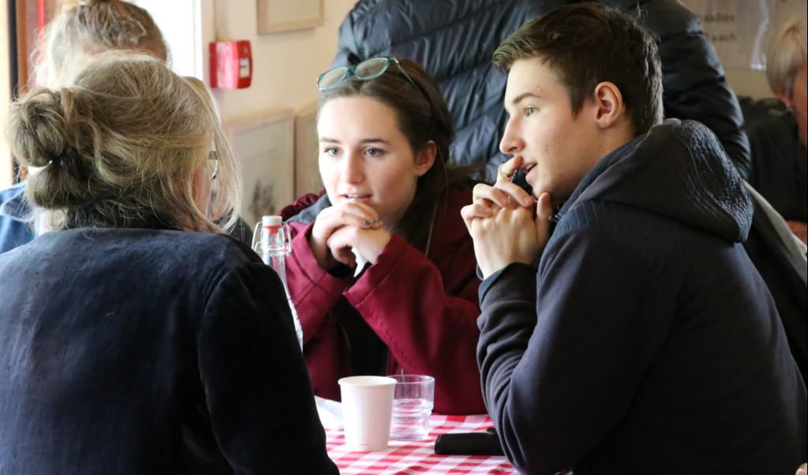
To change a System you must change Consciousness
Among the ideas that animated the conversation was that changing a system, but particularly one as conservative and complex as education, requires a transformation in consciousness on the part of the participants in the system and the system collectively. Otto Scharmer of MIT reminded us in his opening message to the Symposium that changing consciousness, in turn, requires engaging our deepest and most creative ways of knowing.
Just as a creative education needs to educate the whole person – cultivating the capacity of the open-heart (emotional intelligence) and the open will (learning by doing) as well as the open mind (seeing beyond the limitations of established paradigms) – the symposium would likewise need to engage all these faculties of knowing. In short it would need to embody in its own approach the creative education that was its goal.
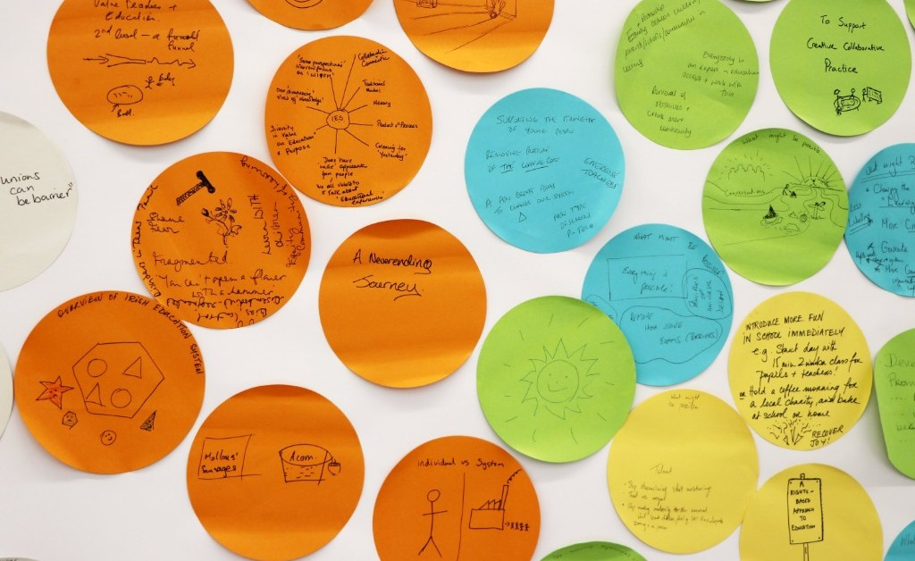
The Process and the Journey: Theory U – in four Strands
The design of the conversation worked within the framework of Theory U developed by Otto Scharmer of MIT. This ‘technology of social change’ is similar to traditional design theory in that it invites an opening of the senses to all available impressions (‘divergence’), retreating to connect to the well-springs of inspiration and purpose (‘transformation’) and bringing the process to fruition in critically-appraised action (‘convergence’).
This was the design for the ‘deep dive’ of the symposium at which there were no keynote-speakers – but there was a ‘keynote listener’. Listening was the key skill and participants were the experts. For the three days of the conversation everyone – from student to policy-maker - would meet as equals shedding titles and representational responsibilities to co-create new understandings and commitments to action.

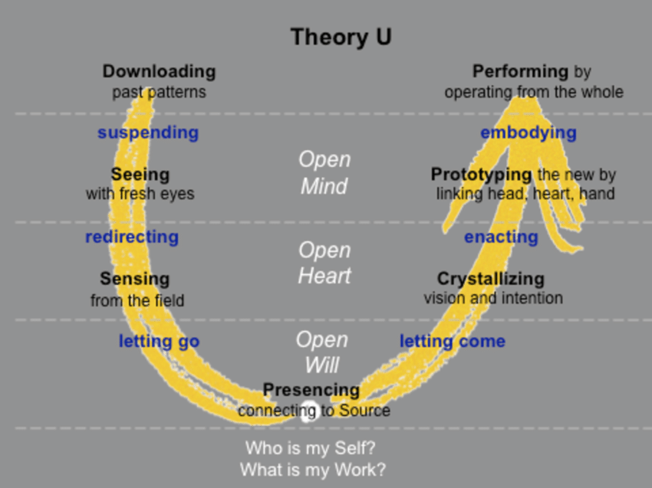
Within this U framework, four broad themes and corresponding approaches were chosen to explore the education system:

- At the macro level the exploration was facilitated through Social Presencing Theatre. Participants made shapes and sculpted in physical form and movement what the system felt like and where it was seeking to go, revealing in the process, powerful insights not accessible by cognition alone. By tuning into group kinaesthetic intelligence, the process revealed aspects of alienation experienced by marginalised students, despite the best intentions of those in authority. Teachers were being pushed too far out and the system was seen to serve the most able student. While emotions were disturbing to observe, the felt sense of vulnerability was a potent force for change. Other insights included how the business sector could act as a resource in a more equitable system.
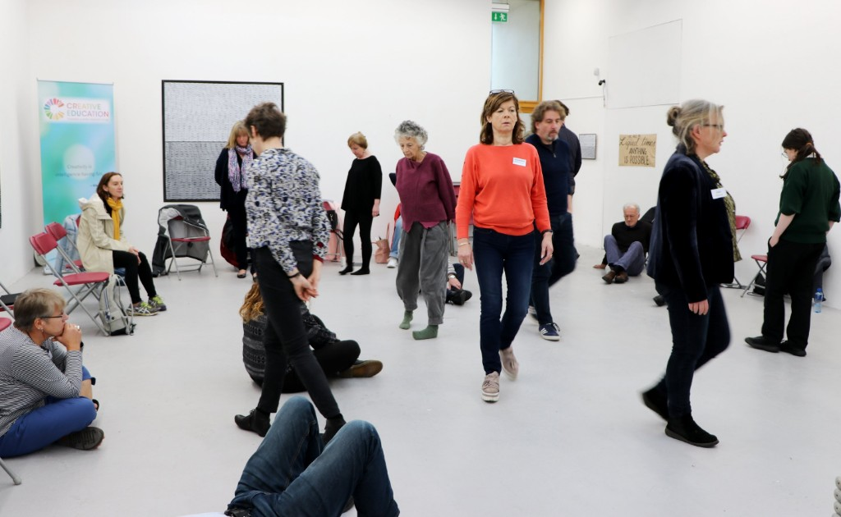
- At the micro level the group were asked to reconnect to their personal experience of the classroom, a process that uncovered conflicting perspectives between the older and younger members. The dynamics of the teacher/student interface were explored. This was revealed to be a fertile area where, by re-imagining relationships, there was significant potential for new ways of learning. On the third session the younger participants became the facilitators and led the adults through a prickly but rich conversation around personal vulnerability and creating a culture of sharing and acceptance instead of a culture of fear. A provocative question emerged at the end: ‘Can we break the system without breaking the participants in it?’

'Creativity is what makes us human. We are here to witness the beauty of the universe. I’m glad students did facilitation – it was very powerful.'
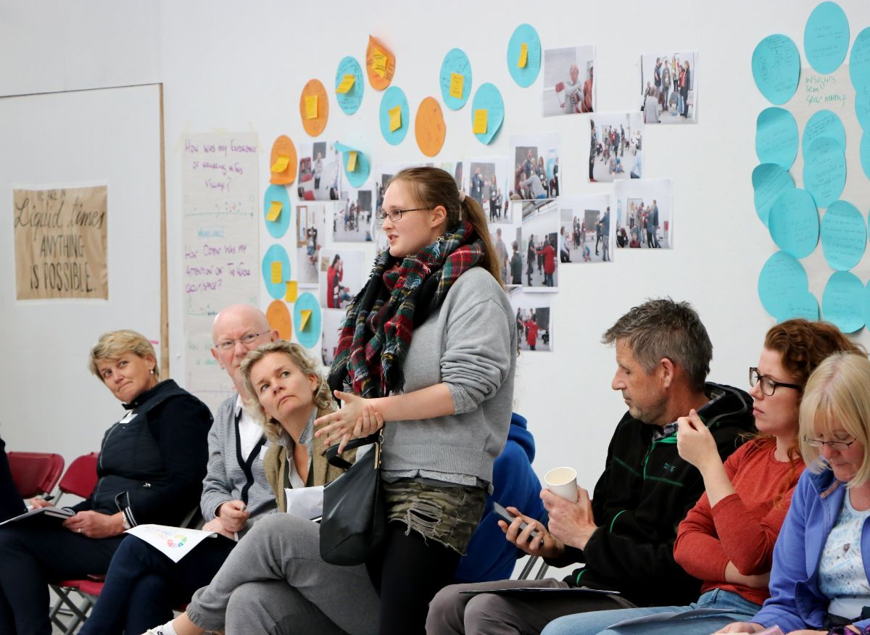
Time to disrupt the system and for students take centre stage.

‘Making visible the invisible’ sought to challenge the dominance of the written and spoken word, deploying visualisation techniques to facilitate embodied, multi-sensory experiences. 3D modelling enabled representations of the education system to be built that captured the more intangible forces and relational dimensions of the system in addition to the material and the human. A sensory walk helped hone the senses, before returning to the 3D models to consider the areas requiring most urgent attention.
Through these predominantly visual processes, participants sought to capture the complexities and nuances of the system - a curriculum that is slow to respond to change, teachers who are not adequately supported to meet the challenges they face and the need to rediscover empathy and compassion between teachers and learners.
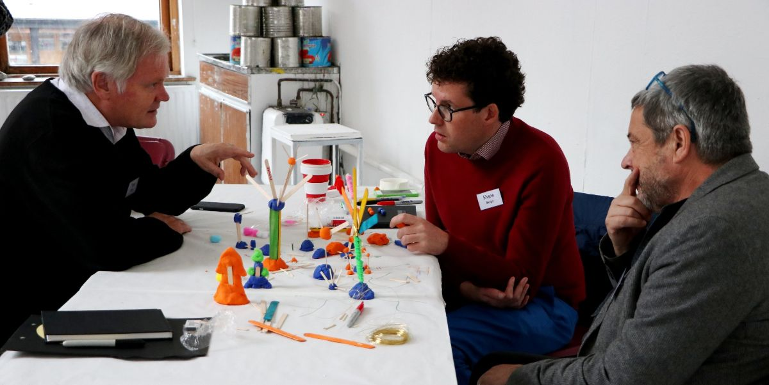
Capturing complexity in visual media
The What’s Unspoken strand explored the ‘what’ and the ‘why’ of things that are not normally spoken about but reside below the surface of everyday discourse. The strand worked primarily through cycles of dialogue and reflection, with a strong emphasis on safety and inclusion of multiple perspectives. Key insights were the recognition of the many issues that are known to matter and that need to be included in our conversations. Some of the factors that inhibit such conversations were recognized as fear; the need to feel ‘in control’ and not rock the boat too much; the lack of suitable contexts in which to deal with difficult issues well, and the lack of a unifying vision.
Among the questions that participants wanted to do more work on were:
- How to create safe spaces for fearless, wholesome conversations about the Leaving Cert and what it could be replaced with.
- How to ‘un-learn’ our given understandings of education and be open to diverse models.
- How to educate for society and what that might mean; why some, particularly the poor, feel alienated from the system.
- How exhausted teachers can be supported to speak about their experiences and get more support.
- How to trust teachers and empower students; the role of education in the context of very rapid technological change that is making many roles redundant?
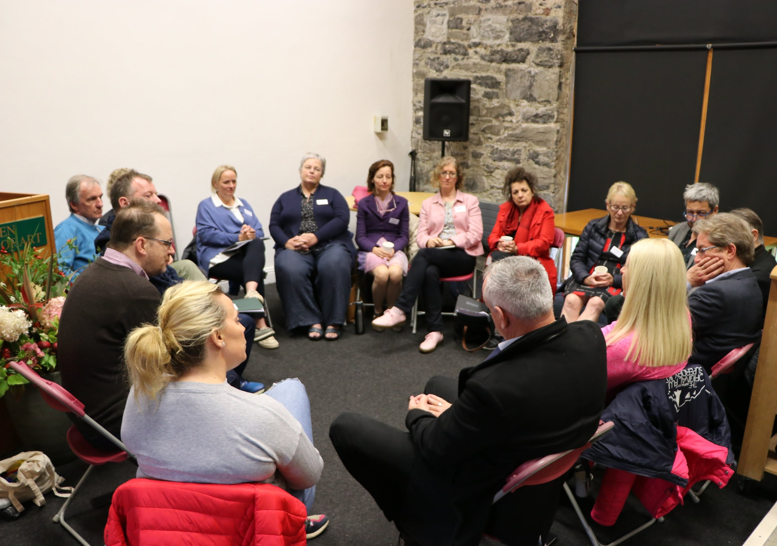
The Plenary Sessions allowed the four strands to cross-fertilise with music opening space for new insights to emerge. We were reminded of the importance of the space between the notes and taking time to experience each note fully. It takes only five key notes/themes for musicians to collaborate and improvise. Half of the job in life is showing up and being vulnerable!
What we heard in plenary gatherings was of a system arrested in patterns of stuckness, seeking to transcend difficult thresholds. The forces of fear and control were inhibiting progress. There was a need to break open the system without breaking the people in the system. We could start by simplifying the agenda, creating ‘a common vision for an uncertain future’ that would state what we value and what we imagine the purpose of education to be at this time.
Could we give ourselves permission to be vulnerable and address taboos? Do we need schools? Were we willing to confront entrenched power structures and vested interests and prioritise discretionary resources towards the under-privileged even at the expense of our own privileges?

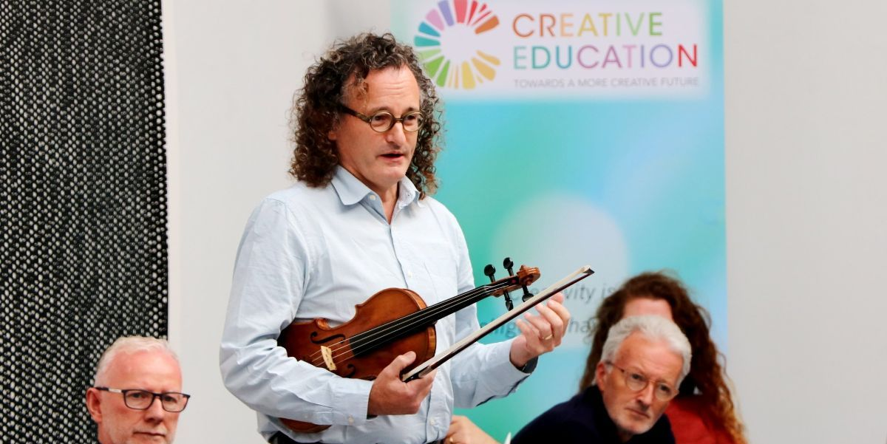
Creating spaciousness for transformation to happen

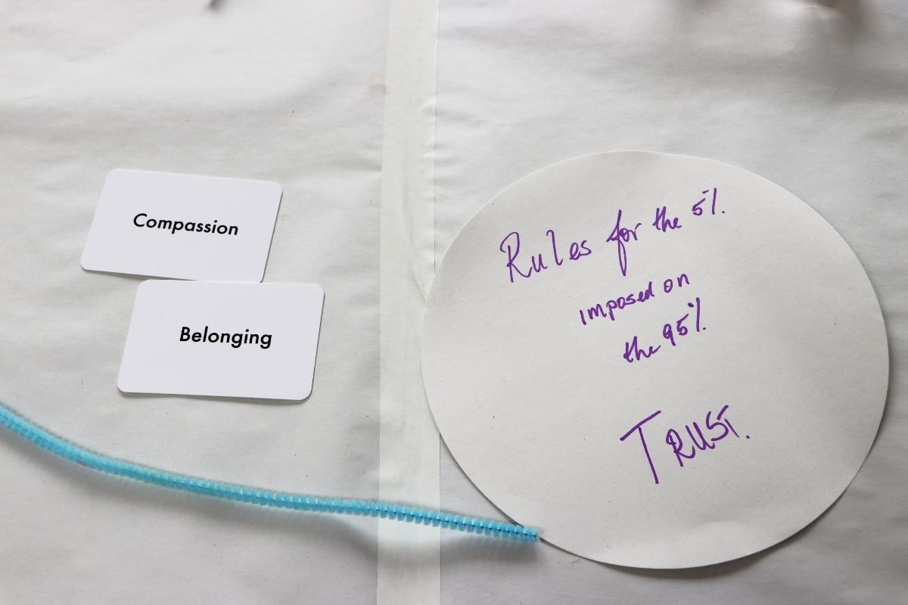
We need Trust, Compassion and Belonging

There was a strong sense that the voices of students needed to be amplified and heard. The cultivation of loving relationships with students was necessary. An education of the heart and the will were necessary not just an education ‘from the neck up’. The well-springs of teachers as true professionals needed to be nurtured.
We were reminded that since ours is an Irish education system, we have access to the deep wellspring of the Irish tradition. ‘Tá dóchas sa dúchas’. Opportunities for greater spaciousness (‘tóg sos’) and opportunities for nourishment at the ‘tobar’ of renewal were essential. Life and education needed to be viewed as a dance not just a journey.
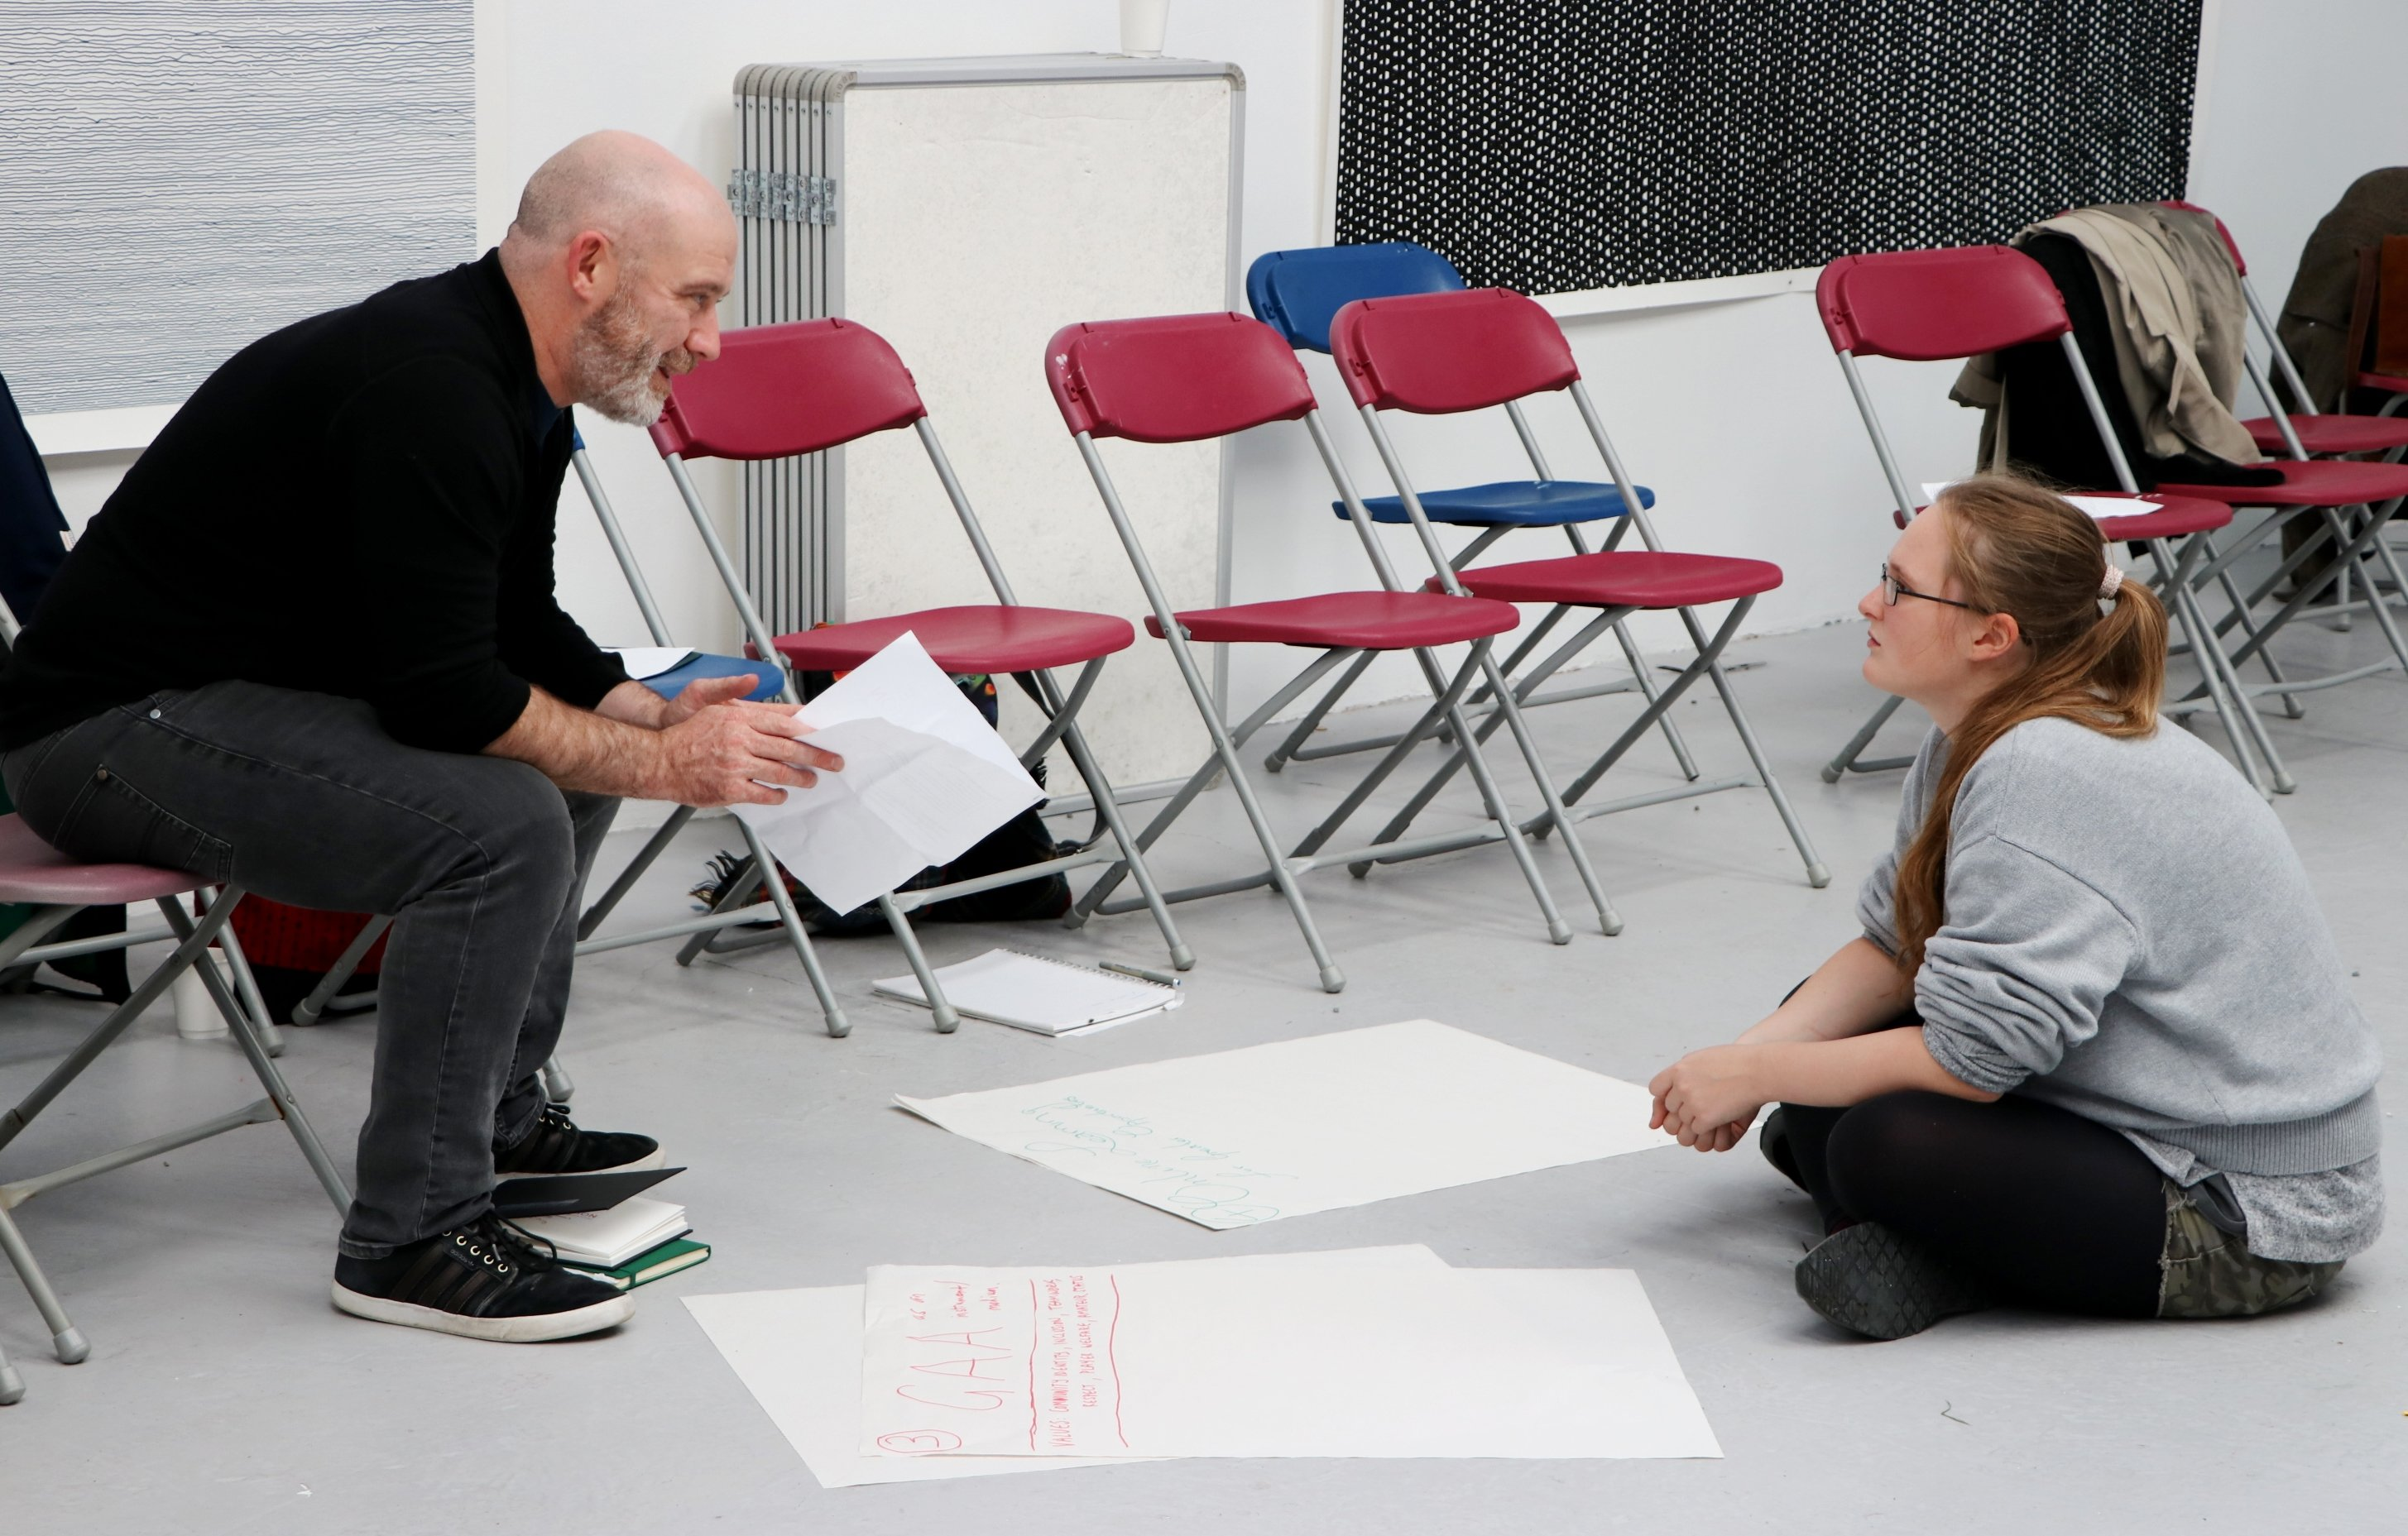
'I’m looking for an Irish sense of education. It needs heart.'
The Harvest – be the change you want to see in the world
A creative process, of its nature, is not amenable to control. The intention may be clear - to catalyse a process capable of overcoming the forces of inertia, fear and conservatism and moving the education system in a more creative direction. However, having created the incubator conditions and processes it is necessary to let go of control and make space for the future that is seeking to emerge to come into being. Initiatives will find their own rhythm as actors respond in their own ways and in their own contexts to the impulse to ‘be the change’.
The complex multi-layered nature of the process is captured in this Matrix over-view of the process and its outcomes, the Graphic Harvest which transcends the limitations of the verbal; the video of the event and the photographic archive.
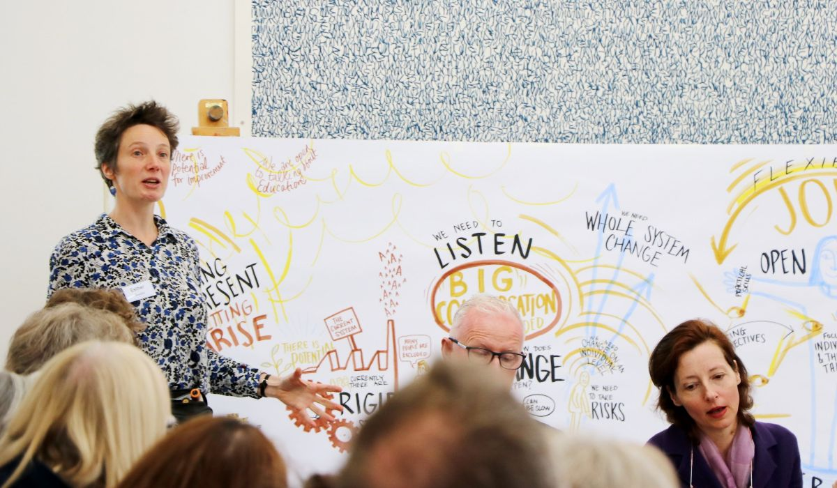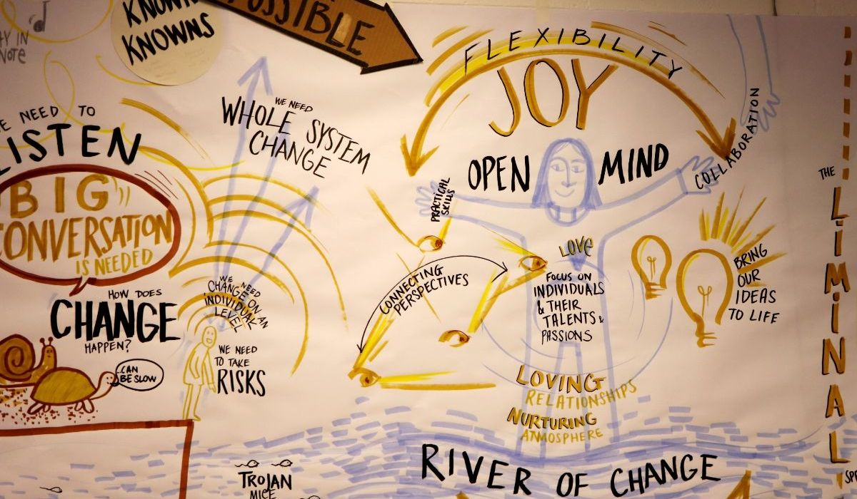
As the symposium came to its conclusion with thematic clarity emerging around the importance of purpose, creativity, the arts and the imperative of moving the Burren process forward there was a clear sense that transformations in understanding were under way.
It was asserted that ‘the quality of interior conditions is very high’ and that we should ‘suspend meaning-making for as long as possible’ to allow richer understanding to emerge. The energy and inspiration that were evident in the closing contributions suggested that the conditions were right for the prototype initiatives that had been sown during the symposium to take form.
At the level of the larger system the Wild Atlantic Way of Education (WAWE) has already assembled a growing group of supporters which has begun exploring the promulgation of the process begun in the Burren into more localised engagements by parents, students and teachers:
'Just as the ‘Wild Atlantic Way’ gave us a new way to view what already existed these days give us a new way to view education.'
'Teachers have transformed my life. For many, school wasn’t a transformative experience. I want to carry the conversation process forward.'

The ‘Citizens Assembly for the Reform of Education’ prototype, which garnered huge support, awaits the first convening of its support group:
'If we feel stuff is happening that is suffocating we are called to act.
I will pursue what’s emerging – the Citizens Assembly.'
'I’m more and more convinced of the need for civic engagement for
where we need to be.'
'The egotistical rationality of our education system has got us here.
We need a Citizens Assembly.'
'Fifty percent of the Citizens Assembly should be children.'
'I’m pledging myself as a foot-soldier of the Citizens Assembly.'
The potential of the Burren College of Art as a ‘Sane Reflective Space’ for nurturing the personal and professional development for Leaders in Higher Education and show-casing innovative work in education is being explored. Other prototypes such as place-based learning, the re-design of school spaces and many others will find their supporting infrastructure in due course.
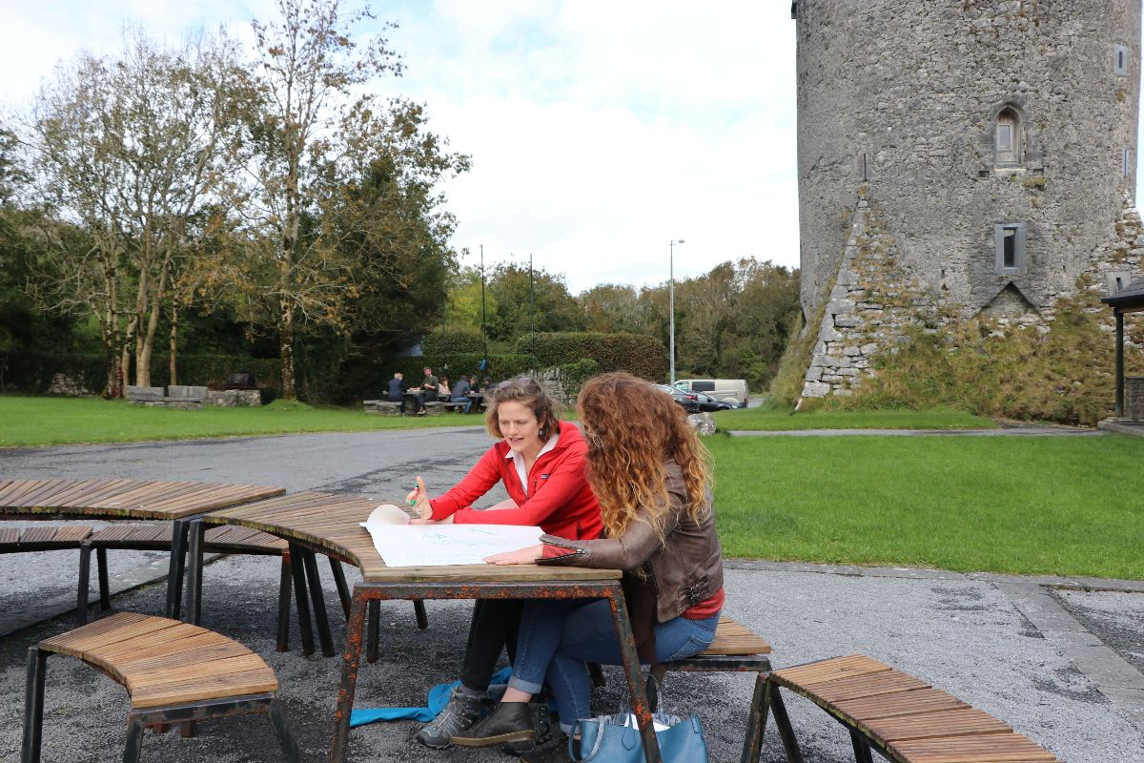
These are but the leading edge of initiatives which have the potential to be transformative at a systemic level. What can only be imagined is the potential for transformation in the personal and professional contexts of those who contributed to the symposium. And over what time-scale might the out-working of these transformations become apparent?
These are part of the latent harvest of the Symposium which, though not amenable to measurement, is likely to have considerable import in seen and unseen ways over time.
The Way Ahead
Welcome to the Conversation
'I implore everyone to be a community of doers. We need to listen and do.'
'The education system doesn’t need reinventing. It just needs everyone to do the thing they are taking away.'
'These three days give hope that it is possible to make things happen.'
'Everyone is a note in the performance. There is a ripple effect we can have on people we meet.'
'We need to plant the seeds of change. What are the essential notes?'
'We are the system. We need to liberate ourselves and the system. There are many others outside the room who share our vision about a more resilient future.'

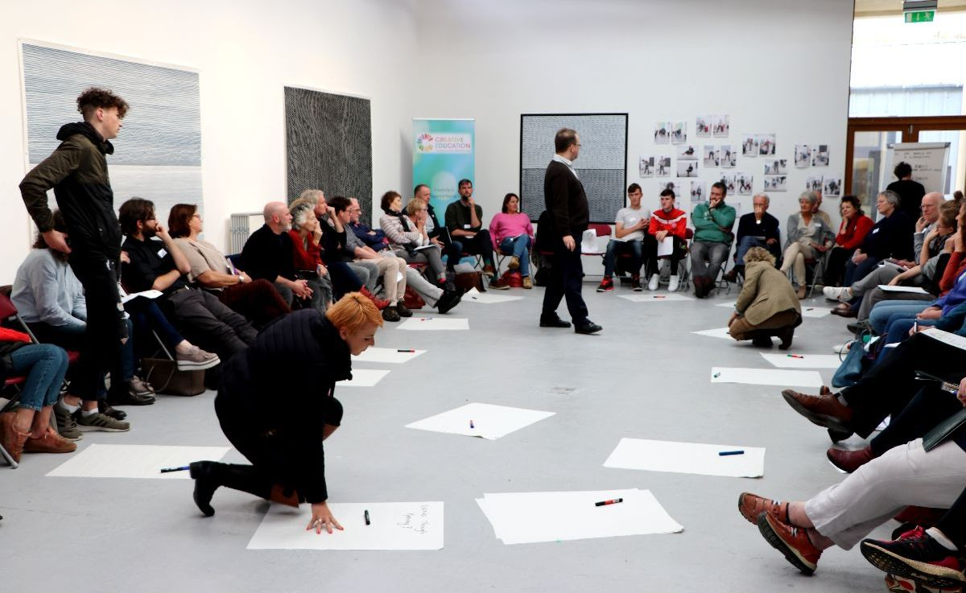
The essence of ‘Towards a More Creative Education System’ is an invitation to be part of an ongoing system-wide conversational process that will enable the education system to move in a more creative direction. The Symposium was not only a catalyst but also a prototype for what such a conversational process might look like. In addition it mirrored what a creative education system itself might look like – cultivating an opening of hearts, minds and wills to new possibilities and inspiring commitment to the transformational action which this time calls for.
For the Symposium’s potential to be realized the conversation needs to continue and be amplified in many places and contexts across the system. The initial signs are promising. Support groups are assembling and initiatives being catalysed which have the potential to move the system in a student-focused direction in which teacher agency and vocation are renewed and where institutional structures support the transfer of initiative from top-down to a co-creative process in which the collective capacities of the system are more fully enabled.
If you feel inspired to be part of this conversation you are invited to contact the Burren College of Art: mhg@burrencollege.ie.
Perhaps the ambition to be the best education system in Europe by 2026 is no longer as aspirational as it once seemed.
'I won’t remember what you said but I will carry with me how you made me feel. Creativity resides in the space between. This special place gave us the strength to excavate all our assumptions.'
Acknowledgements & Thanks
The Symposium and the work that went into its preparation would not have been possible without the generous sponsorship of the TOMAR Trust who gave their backing to what was a new and little understood way of working.
Our thanks also go to artist, Anne Madden, for her generous support and for the following ‘Reflections’ to the Symposium. Anne’s artistically rendered question ‘Two Bees or not Two Bees’ reminded us of the precarious conditions not only for bees but for all creatures on the planet.
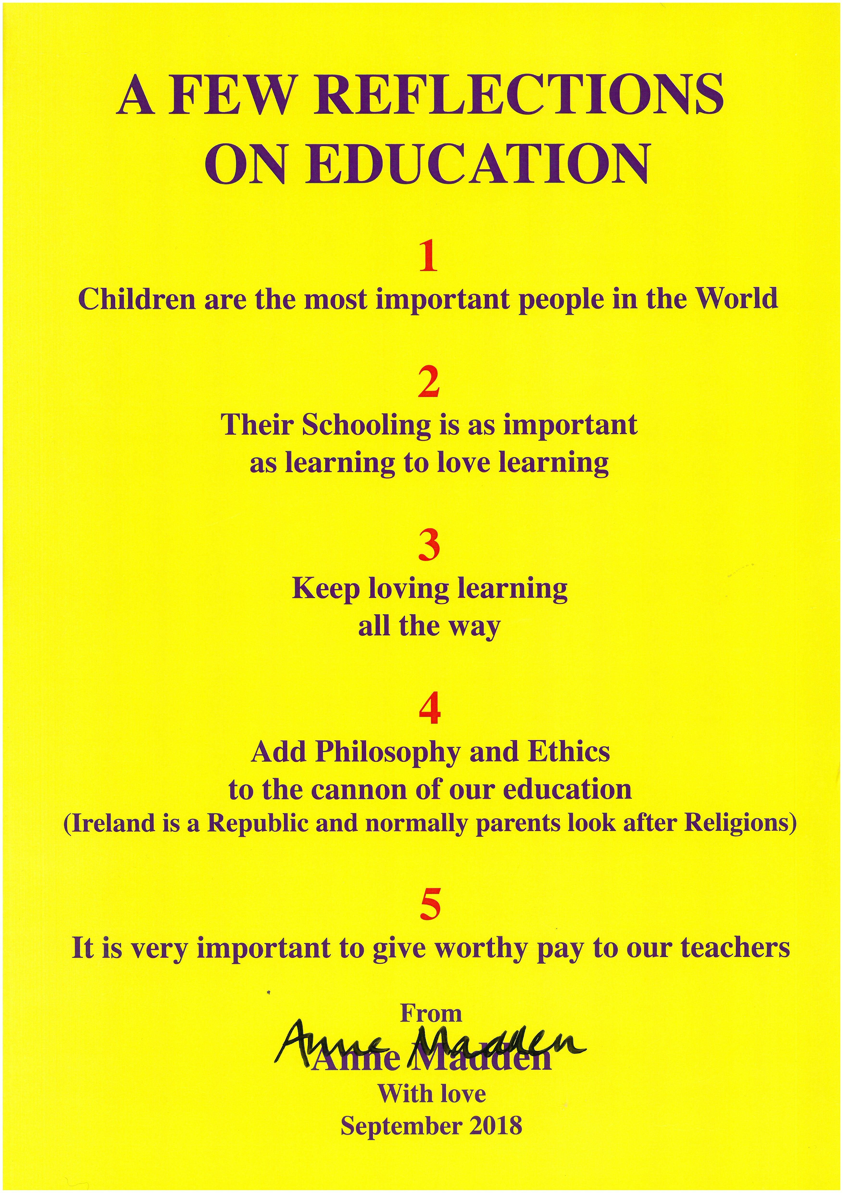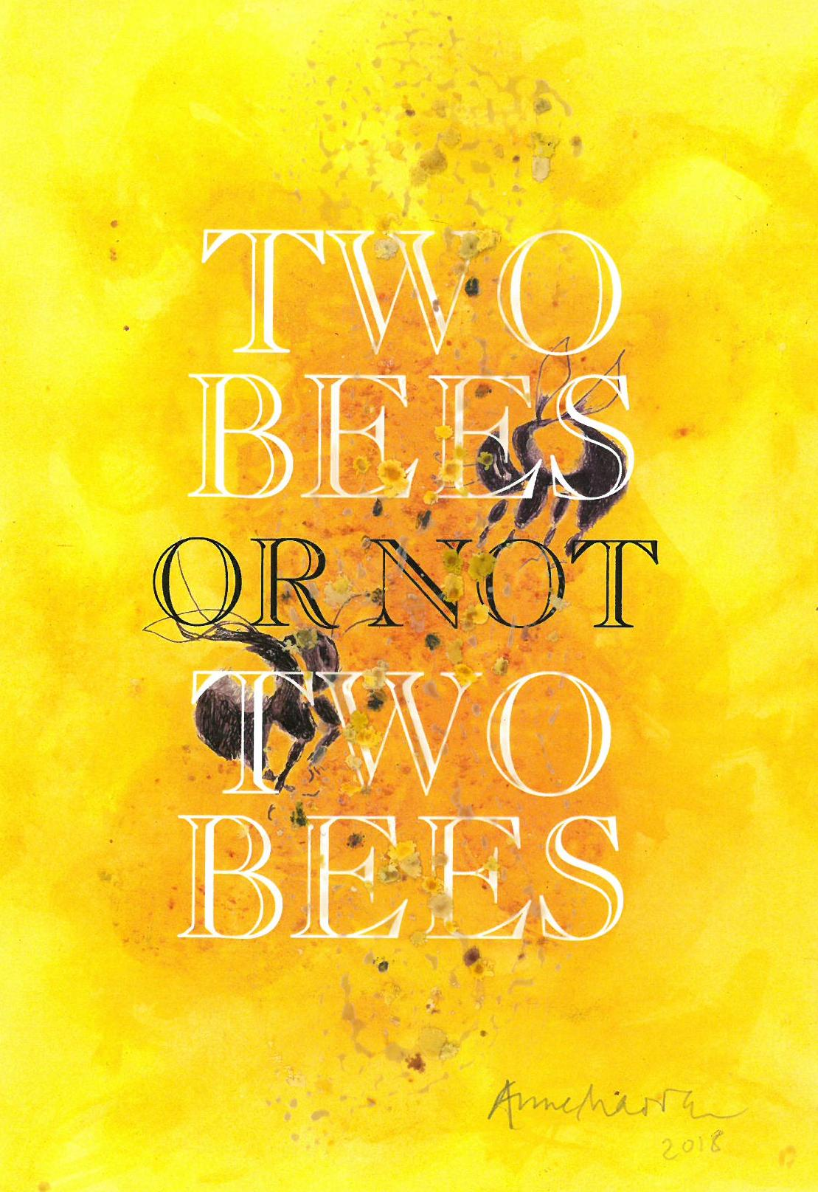

We are also indebted to:
- The team of facilitators led by Chris Chapman - Valerie Jackman, Joan O’Donnell ,Paul O’Gorman and graphic recorder Esther Blodau - who so artfully orchestrated the symposium design and processes;
- Martin Hayes, whose virtuoso playing and presence opened space for transformation to happen;
- Otto Scharmer of MIT, whose opening video comments skillfully set the frame for the conversation;
- Paul Collard for his role as keynote listener;
- Julie Wilson, Founder and Executive Director, Institute for the Future of Learning, whose comments via video held a mirror to the significance of the work being undertaken;
- The very many ‘Voices from the field’ who gave generously of their time and advice in the planning of the Symposium - and many also attended the symposium;
- The National Parents Council Primary for facilitating focus groups with national school students and Spun Out for facilitating engagement with 2nd level students and
- The staff of the Burren College of Art.
Finally our thanks are due to all the participants in the Symposium who had the courage to step outside their comfort zones to participate in what may well have seemed a risky adventure. The passion that so evidently fuels so many in the field of education provides hope that the transformations that are necessary at this time can and will be accomplished.
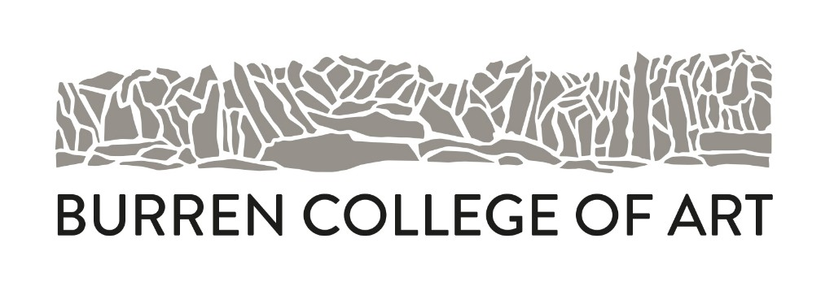
Centre for Universal Creativity
Burren College of Art | Newtown Castle | Ballyvaughan | Co. Clare

